**DEVELOPER SETUP DOCUMENTATION**

1. Operating system installation

Go to the Windows 11 download page.

Under Windows 11 Installation Assistant, click Download Now.

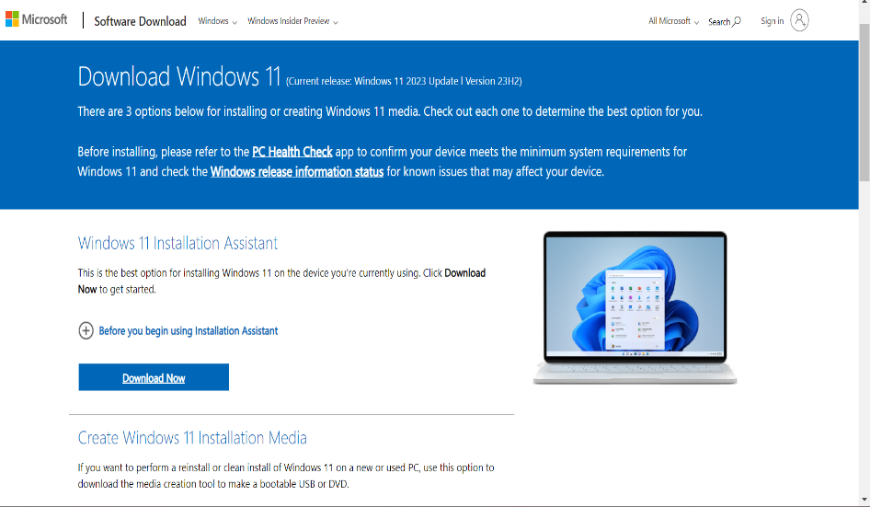

Run the file you downloaded.

If your PC meets the Windows 11 requirements, you'll see a license agreement. Click Accept and install.

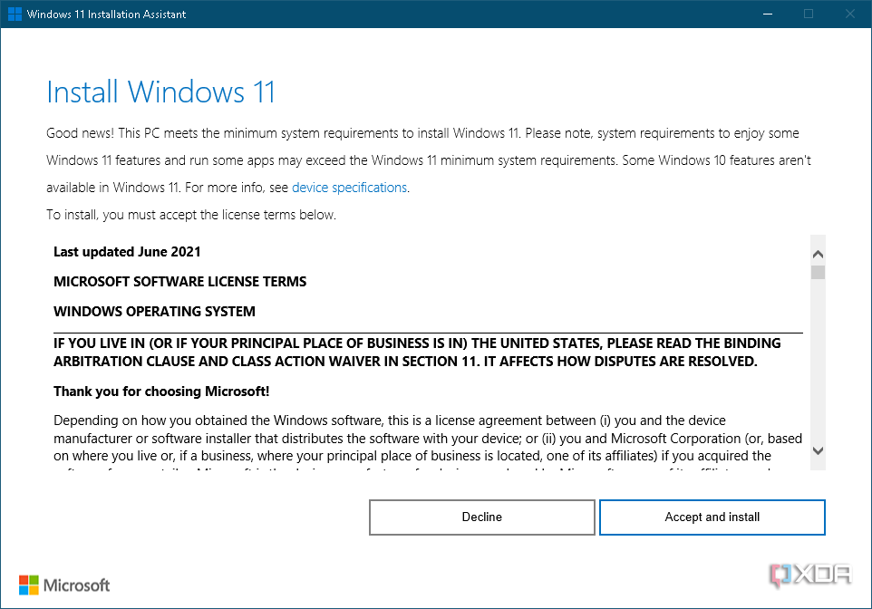

Windows 11 will begin downloading, and you can then follow the steps to finish installing the update.

1. IDE INSTALLATION

Step 1: Download Visual Studio Code

Go to the Visual Studio Code download page: https://code.visualstudio.com/Download

Click on the download button for your operating system (Windows, macOS, or Linux).

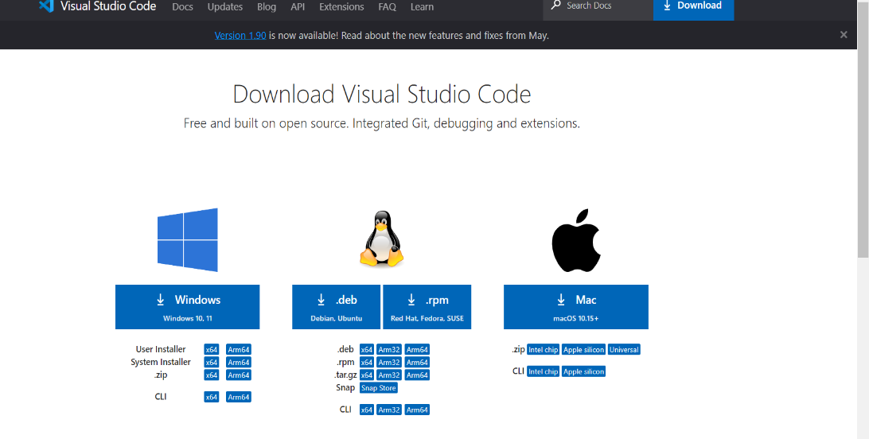

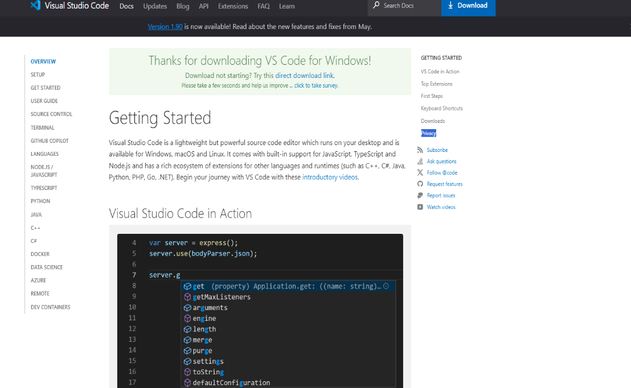

Step 2 Once the download is complete, run the exe file to install Visual Studio Code. The setup wizard should have started. Click “Next”.

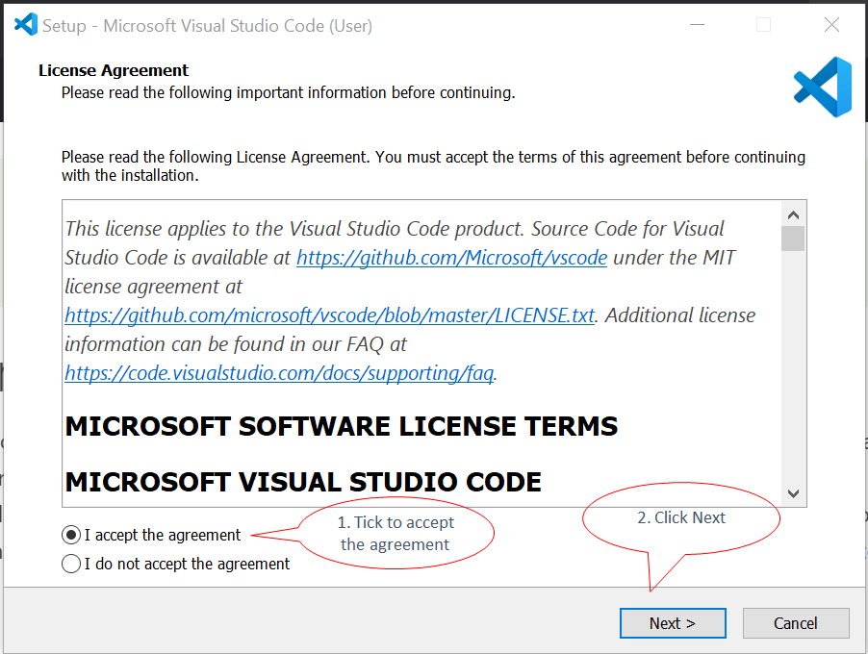

Step 3 in the next screen, change the installation path if required, else leave it and click next.

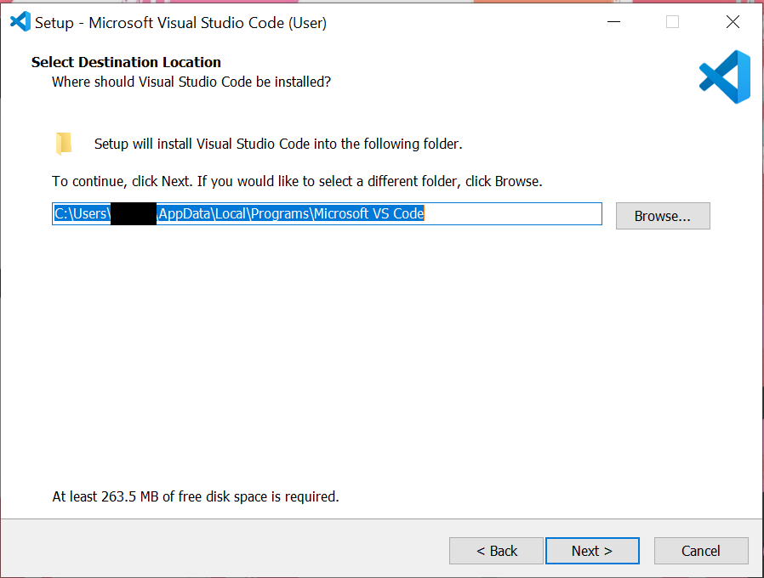

Step 4 Just click next

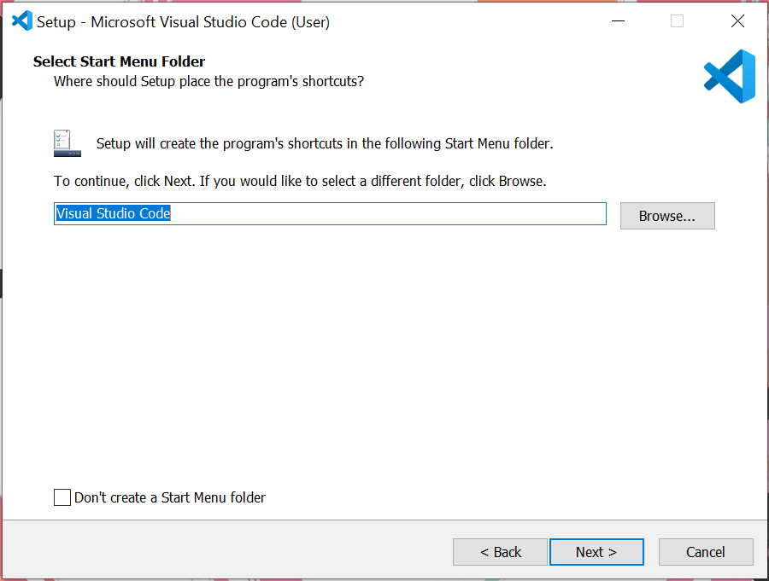

Step 5 click Install.

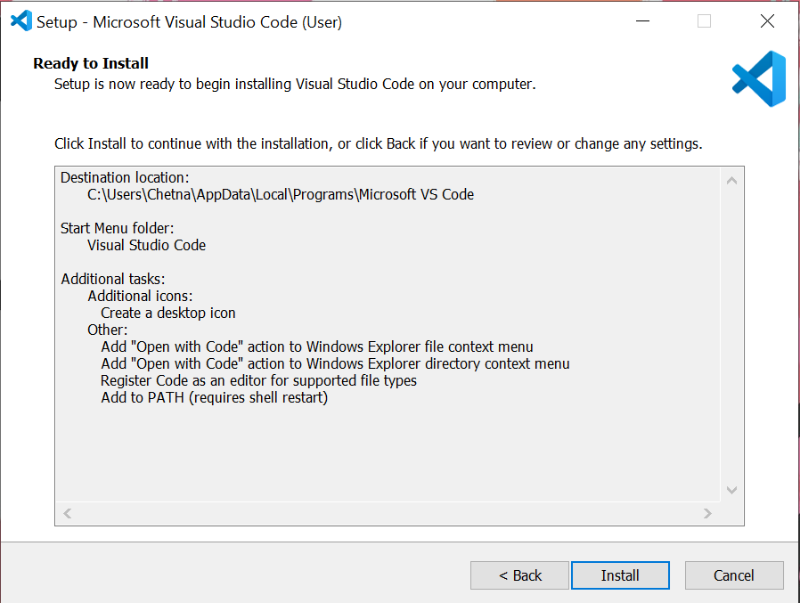

Step 6 Wait for the installation to finish.

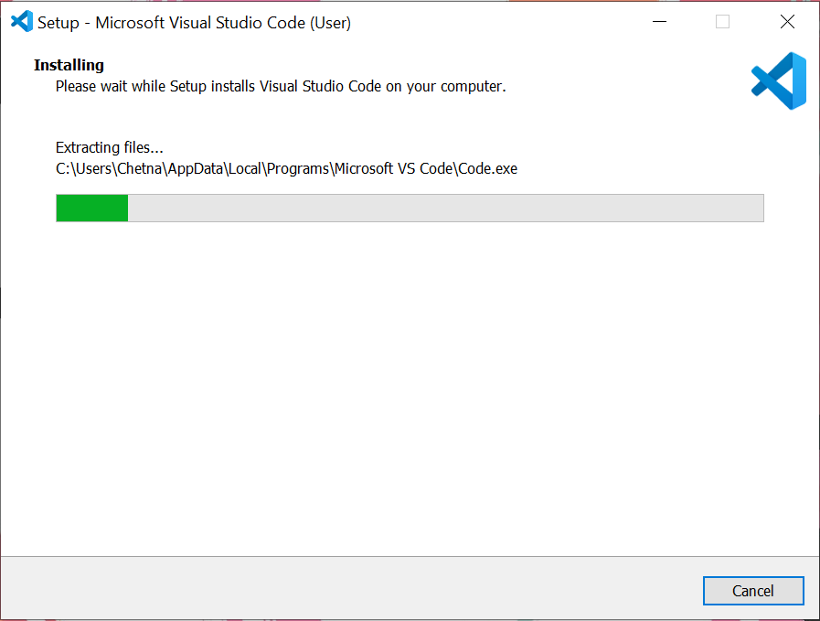

Step 7 Click finish to complete the installation. as the Launch Visual Studio Code option is checked it will open the VS code screen.

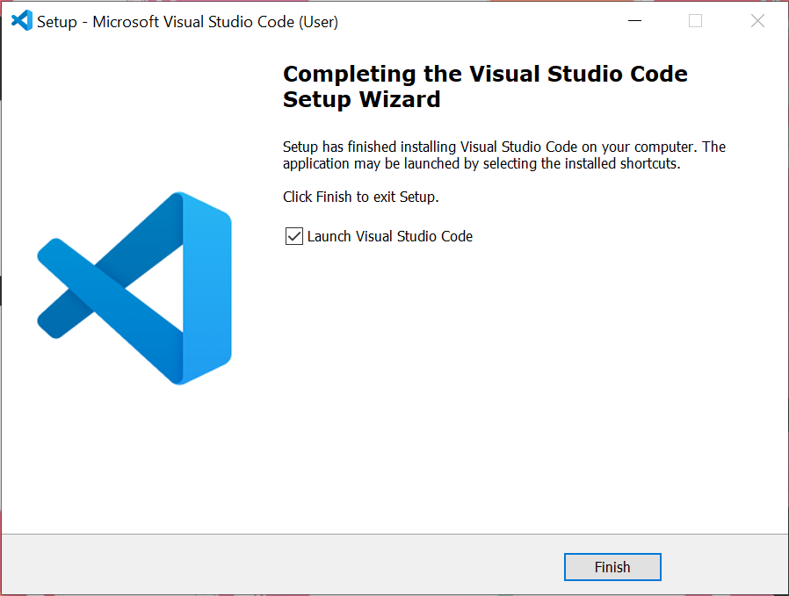

1. VERSION CONTROL SETUP

**INSTALL GIT**

Navigate to the [official Git downloads page](https://git-scm.com/download/win) and click the download link for the latest Git version for Windows:

Depending on the OS you’re using you can choose which to download.

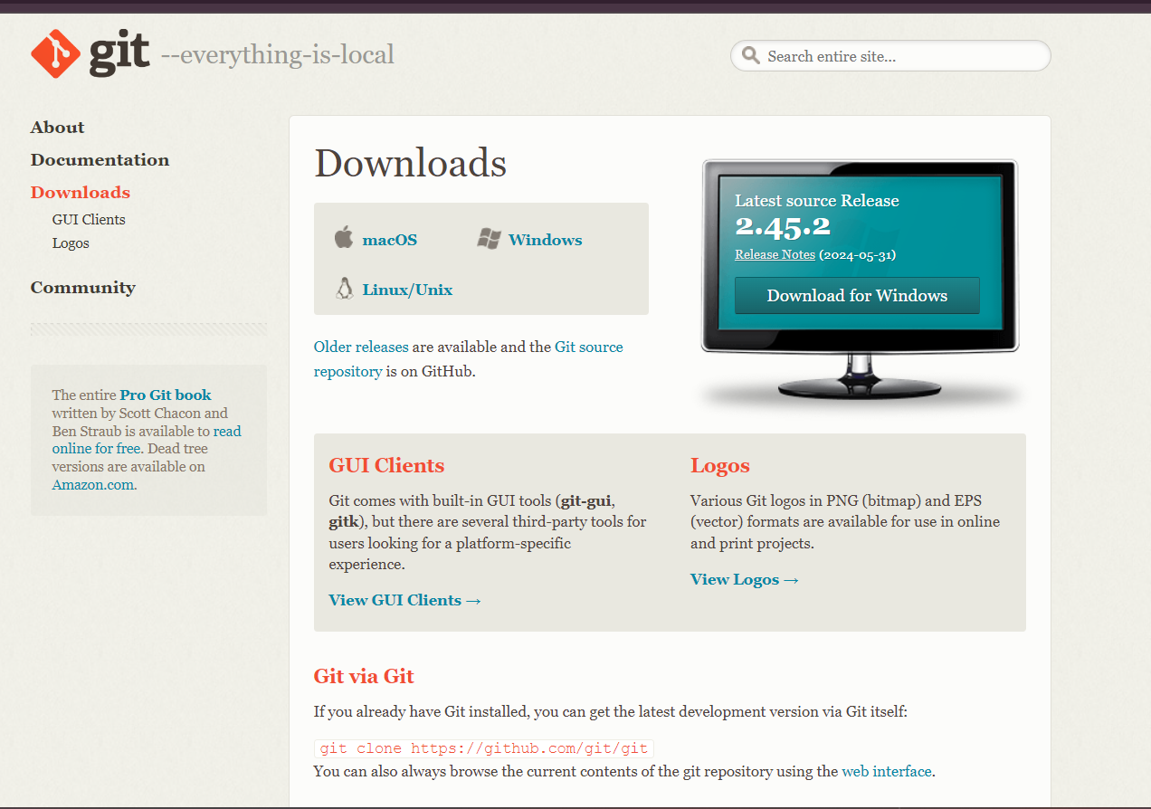

For windows click on the download prompt to download the 64bit

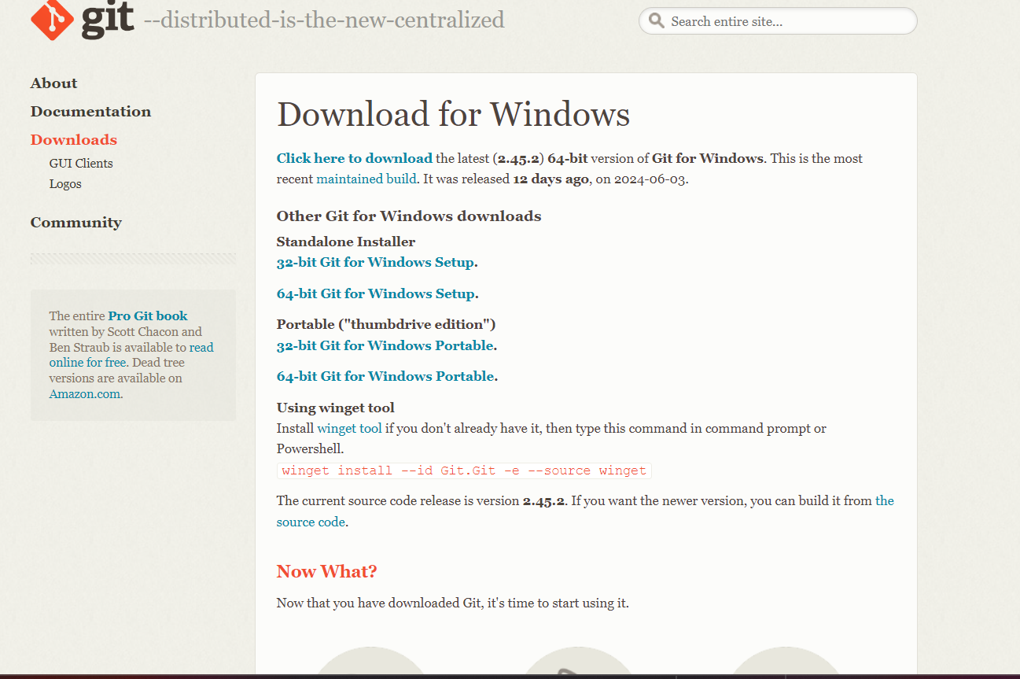

2. Double-click the downloaded file to extract and launch the installer.

1. Review the GNU General Public License, and when you are ready to install, click Next.
2. The installer prompts you for an installation location. Leave the default one unless you want to change it, and click Next.
3. In the component selection screen, leave the defaults unless you need to change them and click Next.
4. Then click on the install button.

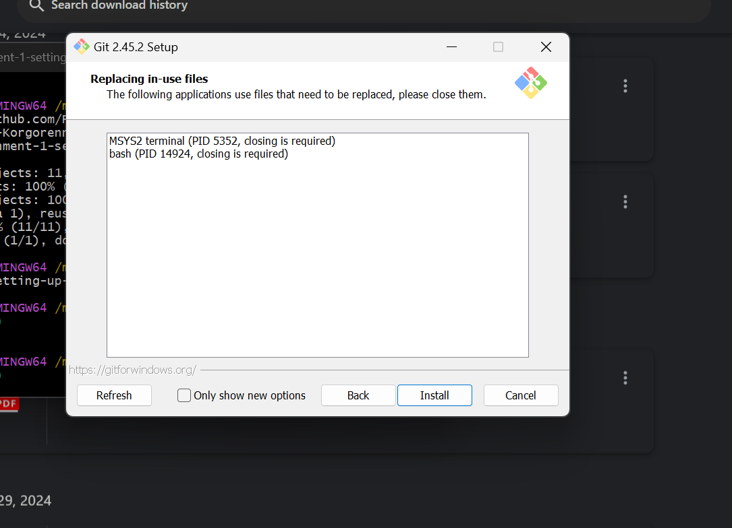

NB !!! MINE IS READING THIS WAY BECAUSE I ALREADY HAVE ONE RUNNING ON THE BACKGROUND FOR THE PURPOSE OF THE ASSIGNMENT.

1. Once the installation is complete, tick the boxes to view the Release Notes or launch Git Bash if you want to start using Git right away, and click Finish.

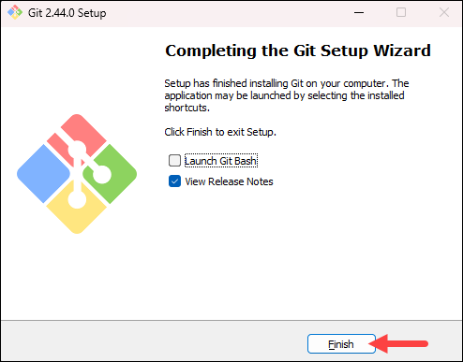

**Configure Git**

Open Git Bash and configure your Git username and email. These details will be associated with your commits.

Run the following commands on your gitbash to configure it.

**git config --global user.name "Your Name"**

**git config --global user.email** [**your.email@example.com**](mailto:your.email@example.com)

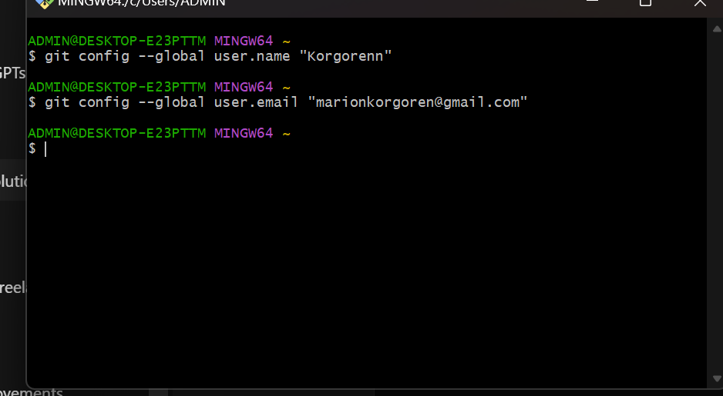

**NB!!! ENSURE THE DETAILS YOU USE ARE THE ONES ON YOUR GITHUB.**

**Creating a GitHub Account**

1. Go to the GitHub sign-up page: <https://github.com/join>
2. Fill in the required information to create a new account.
3. Verify your email address by clicking on the verification link sent by GitHub.
4. If you already have an account just sign in.

**Initialize a Git repository for your project and make your first commit .**

Go to github and create a repository

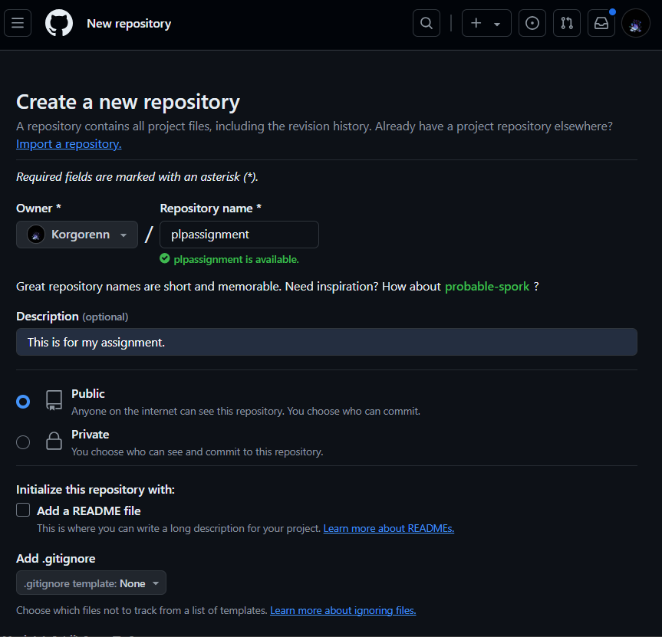

Copy the link below to use in your github

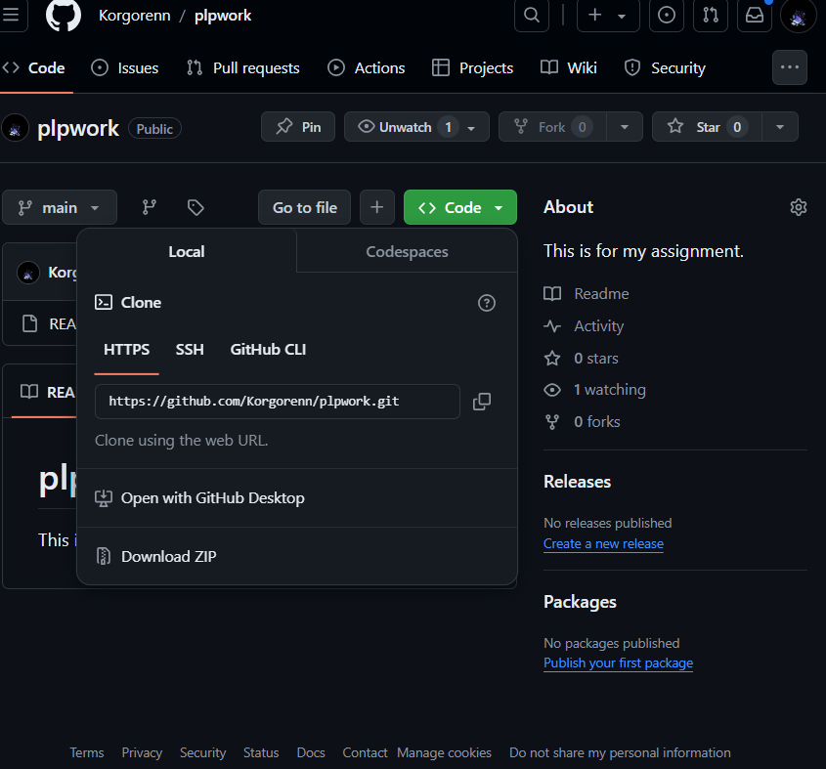

Open your gitbash and run as an administrator

Then run the following commands

NB!! IF YOU DON’T HAVE A DIRECTORY YET START BY RUNNING THE FOLLOWING COMMANDS

mkdir (my-project)-you can replace this with any name of your choice.

cd (my-project)

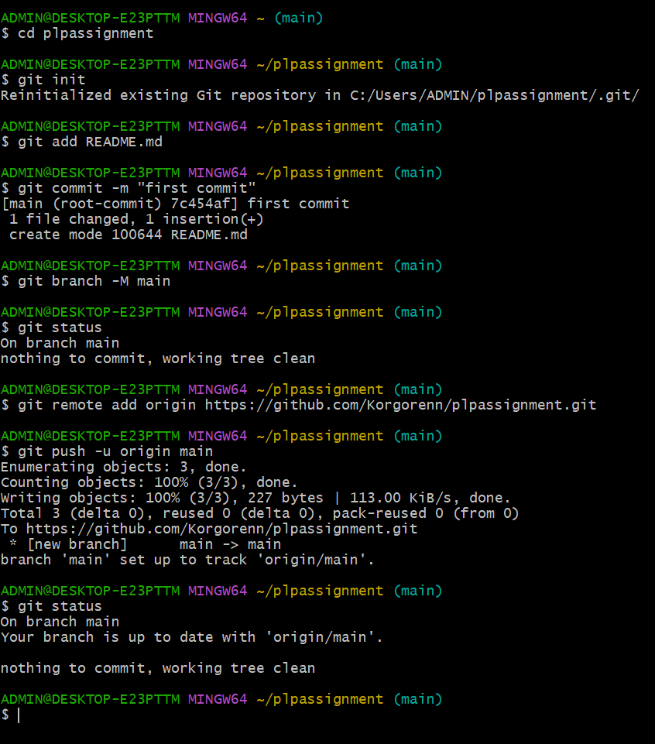

1. PROGRAMMING LANGUAGES AND RUNTIMES

Download Python:

Go to the official Python website at http://wwww.python.org.

Click on the "Download Python" button.

Select the appropriate version of Python for your operating system (Windows, macOS, or Linux).

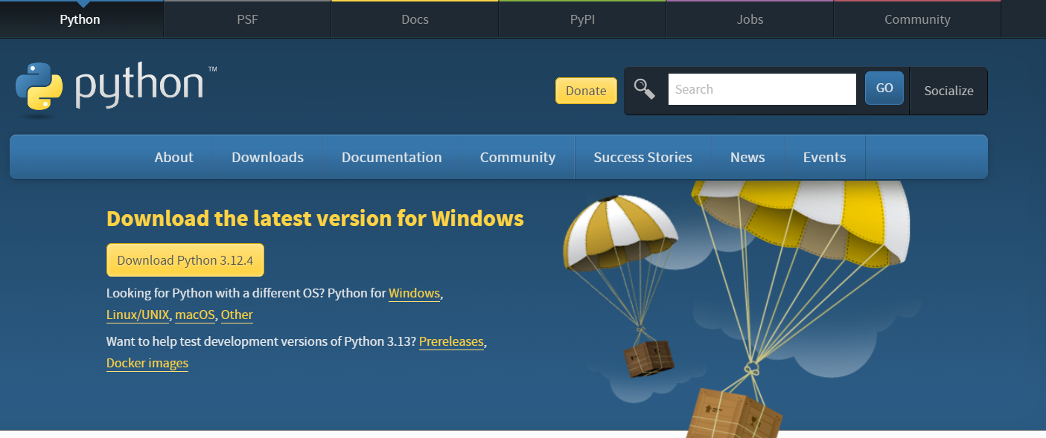

Install Python:

For Windows, download the installer package and follow the installation instructions.

Ensure you check the option to add python to PATH.

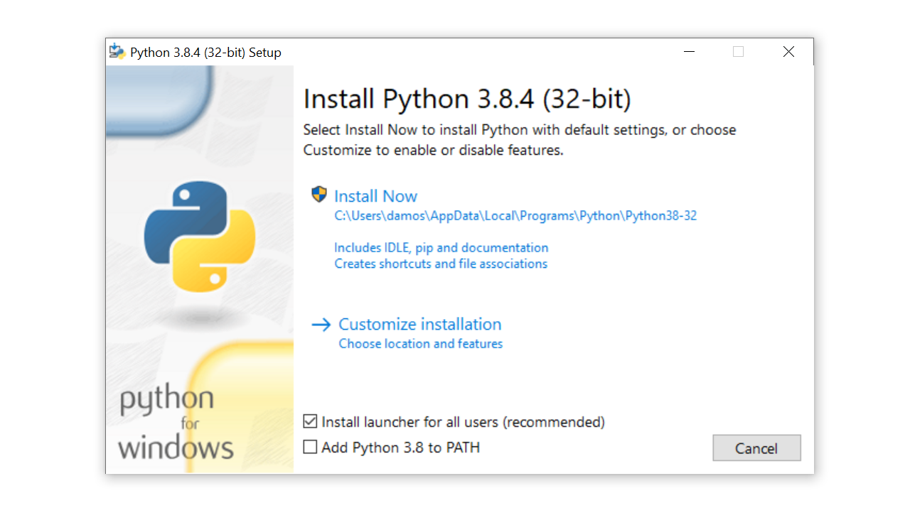

Verify Installation:

After installation, verify that Python is installed correctly by opening a gitbash or command prompt and typing python --version. This should display the version of Python you just installed.

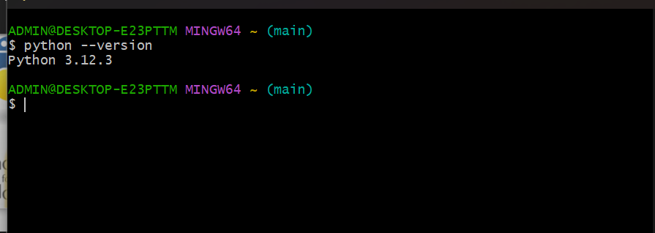

Install Additional Packages:

Python has a vast collection of packages available through the Python Package Index (PyPI).

You can install packages using pip, the Python package manager.

For example, to install the requests package, you would run pip install requests.

Configure Environment Variables:

Ensure that the Python executable is in your system's PATH environment variable. This allows you to run Python from any directory without specifying the full path.

1. **Install Package Managers:**

If you had already installed it you can run the following commands on gitbash to confirm it.

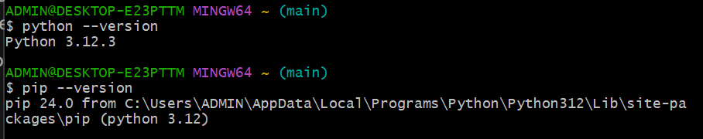

1. **DATABASE CONFIGURATION**

* Go to the MySQL download page for Windows: <https://dev.mysql.com/downloads/windows/installer/5.7.html>.

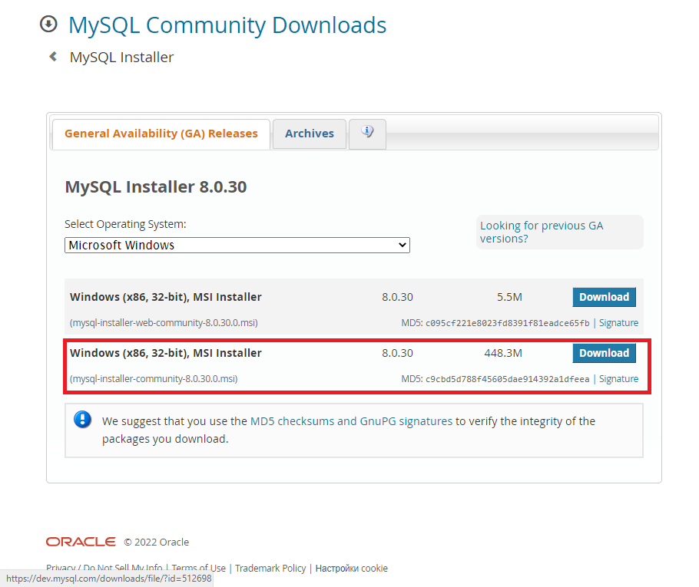

Once you select the option, the service will prompt you to register an Oracle web account or log in with your existing data. You can skip this step. And go ahead and download it.

**Installing MySQL**

After successfully downloading the file, you will need to run it.

Unless you know exactly what you need, choose the full installation ("Full").

After selecting it, click the "Next" button.

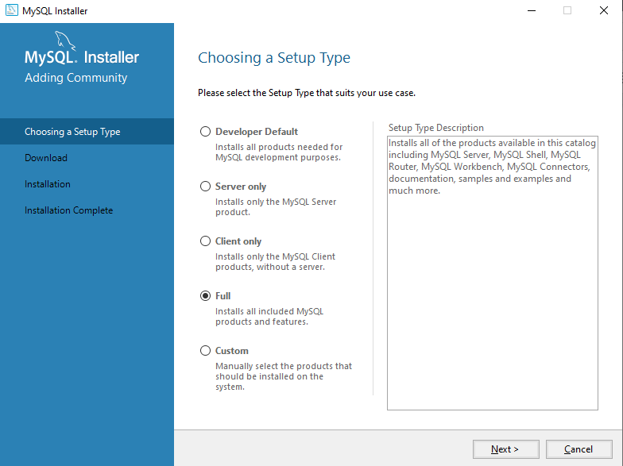

Click on the execute icon

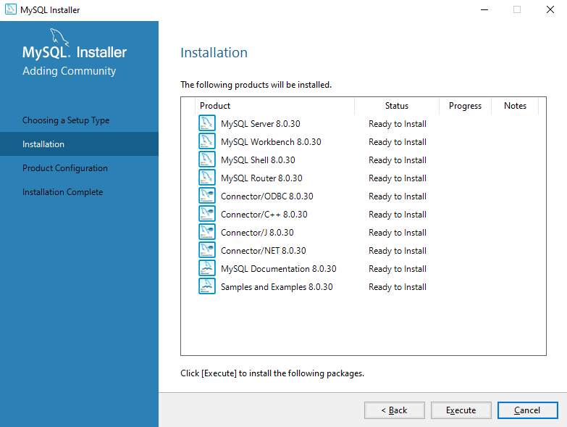

Once done with installation click next.

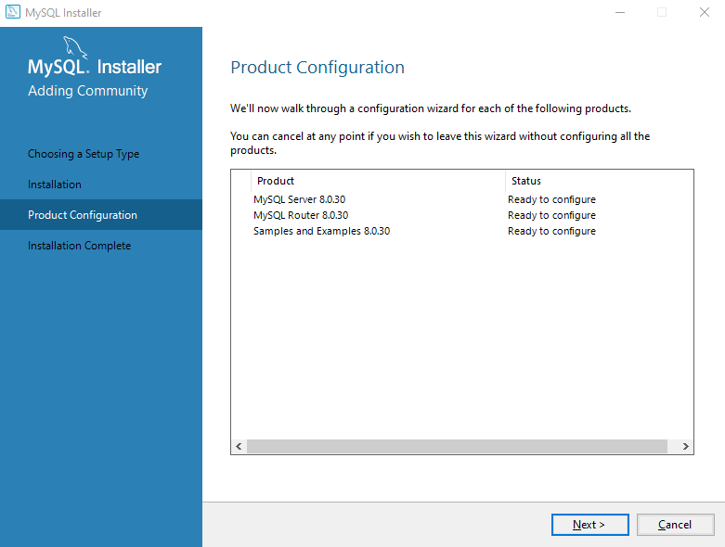

**Setting up MySQL Server configuration**

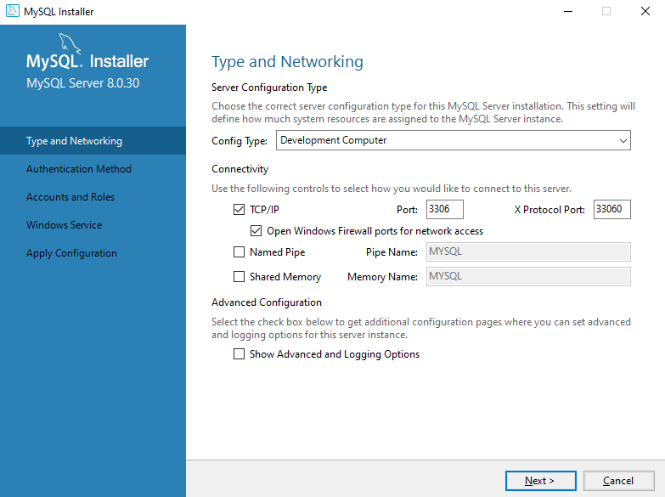

**Choose the "Use Strong Password Encryption for Authentication" option.**

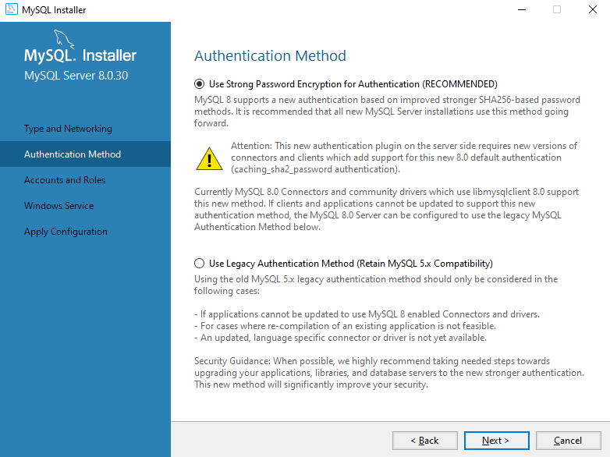

Set a password for the root account.

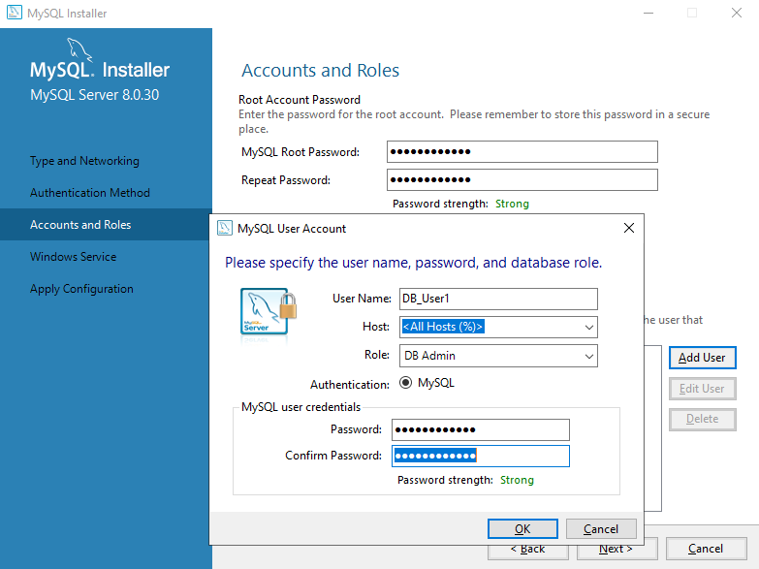

Configure the Windows Service to start the server.

Apply the server configuration by clicking the "Execute" button.

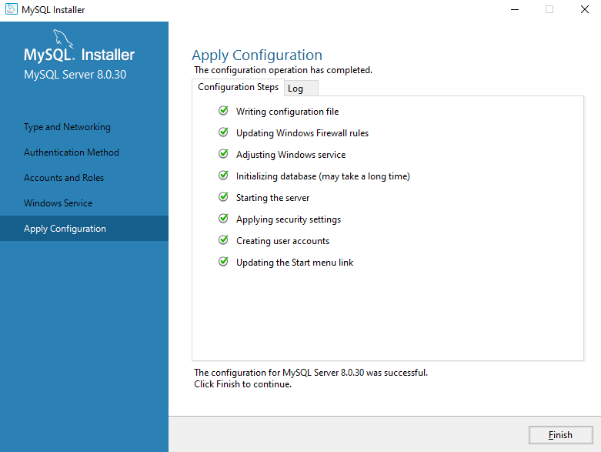

The installation is complete. Click "Finish" to complete the process.

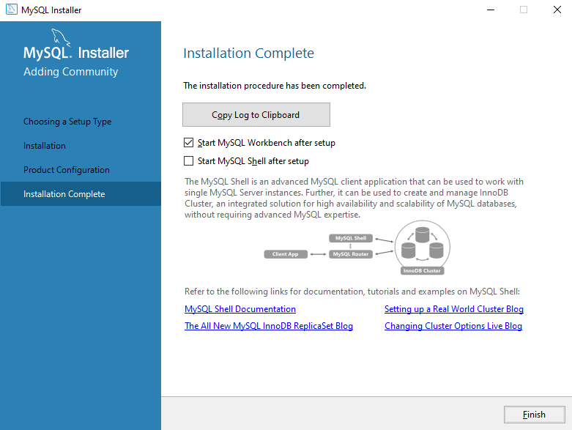

Verify Installation

Open the MySQL Command Line Client from the command prompt.

You should see a mysql> prompt. If you have set a password, enter it to connect to the server.

And you will see a working workbench

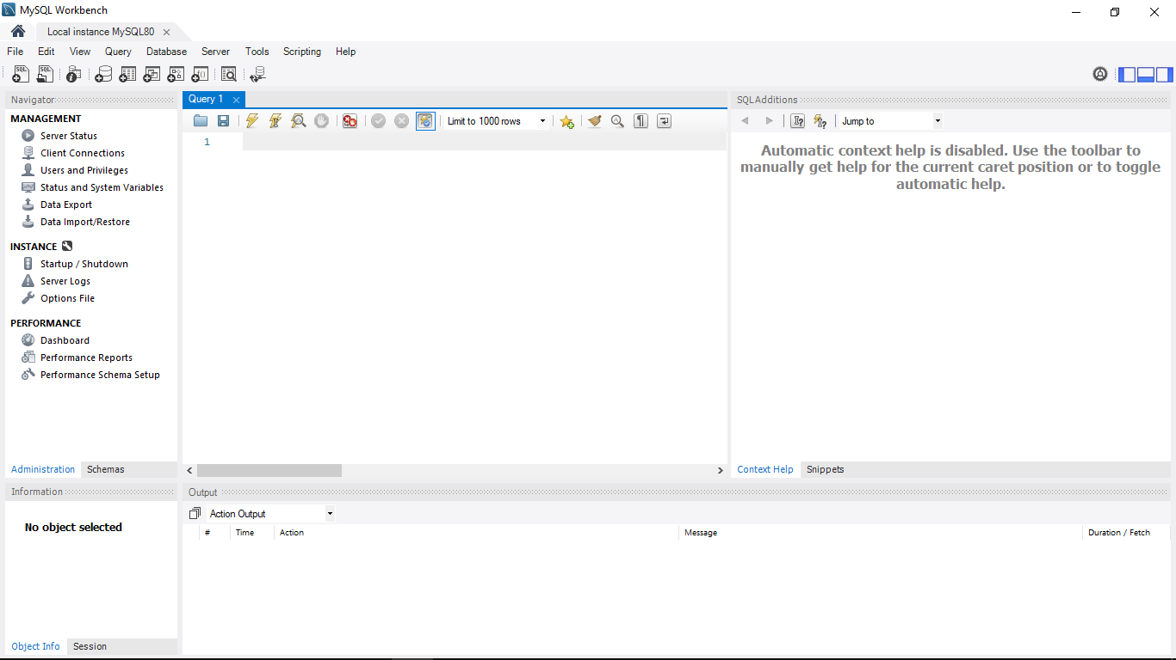

1. **DEVELOPMENT ENVIRONMENTS AND VIRTUALIZATION (OPTIONAL)**

Step 1: Download the Docker Installer

1. Visit the Docker website and navigate to the Docker Desktop page.
2. Download the Docker Desktop installer for Windows.

Step 2: Run the Installer

1. Double-click the downloaded installer to run it.
2. Follow the on-screen instructions to proceed with the installation.

Step 3: Accept the Agreement and Install

1. Click on the Agreement terms to proceed.
2. Click the Install button to start the installation.

Step 4: Configure the Installation

1. Ensure the "Install required Windows components for WSL 2" option is selected.
2. Follow the installation wizard to authorize the installer and proceed with the install.

Step 5: Complete the Installation

1. Once the installation is complete, click the Finish button to complete the installation.

Step 6: Start Docker Desktop

1. Search for Docker Desktop in the search bar.
2. Click on Docker Desktop to start it.
3. Accept the Docker Subscription Service Agreement window and click Continue.

Step 7: Restart and Enable Hyper-V

1. Restart your PC.
2. Enable Hyper-V by going to BIOS setup and marking the "Enable Turbo Boost on DC" option.
3. Save and exit the BIOS setup.

Step 8: Verify the Installation

1. Open the command prompt or PowerShell window.
2. Run the command docker --version to check the Docker version.

Step 9: Add User to Docker User Group

1. Run the command net localgroup docker-users <users>/add to add the user to the Docker user group.

Step 10: Verify Docker Installation

1. Run the command docker run hello-world to test the Docker installation.

NB!!! I DIDN’T OPT FOR IT

1. **EXTENSIONS AND PLUGINS.**

Step 1: Open the Extensions View

1. Open Visual Studio Code.
2. Click on the Extensions icon in the left sidebar or press Ctrl + Shift + X (Windows/Linux) or Cmd + Shift + X (macOS).

Step 2: Search for Extensions

1. In the Extensions View, search for the extension you want to install using the search bar at the top.
2. You can also browse through the available extensions by clicking on the different categories or using the filters.

Step 3: Install the Extension

1. Click on the extension you want to install to open its details page.
2. Click the "Install" button to install the extension.
3. If prompted, confirm that you want to install the extension.

Step 4: Verify the Installation

1. Once the extension is installed, you can verify that it is working by checking the Extensions View.
2. You can also check the extension's settings or features to ensure that they are working as expected.

Step 5: Manage Extensions

1. To manage your installed extensions, click on the Extensions icon in the left sidebar.
2. You can disable or uninstall extensions from this view.

Step 6: Update Extensions

1. To update an extension, click on the Extensions icon in the left sidebar.
2. Click on the "Updates" tab to see a list of available updates.
3. Click on the "Update" button next to the extension you want to update.
4. CHALLENGES AND SOLUTIONS.

The challenge I had when creating this environment was creating the github repo and committing it

Solution- I reviewed the live class recording and read on the github documentation.

Overall, I had a smooth time setting up the environment as it was more of revision to me.

DELIVERABLES

1. Setup documentation
   * This document it has detailed steps and some screenshots illustrating the process.
2. Github repository link

<https://github.com/Korgorenn/https://github.com>

1. Reflection
   * Included on the challenges and solutions section of this document.